Project Design Phase-II
Data Flow Diagram & User Stories

Date | 31 January 2025
Team ID | LTVIP2026TMIDS34879
Project Name | Online Payments Fraud Detection Using Machine Learning
Maximum Marks | 4 Marks

Data Flow Diagrams:
A Data Flow Diagram (DFD) is a traditional visual representation of the information flows within a system. A neat and clear DFD can depict the right amount of the system requirement graphically. It shows how data enters and leaves the system, what changes the information, and where data is stored.
Example: DFD Level 0 (Industry Standard)
Example: (Simplified)
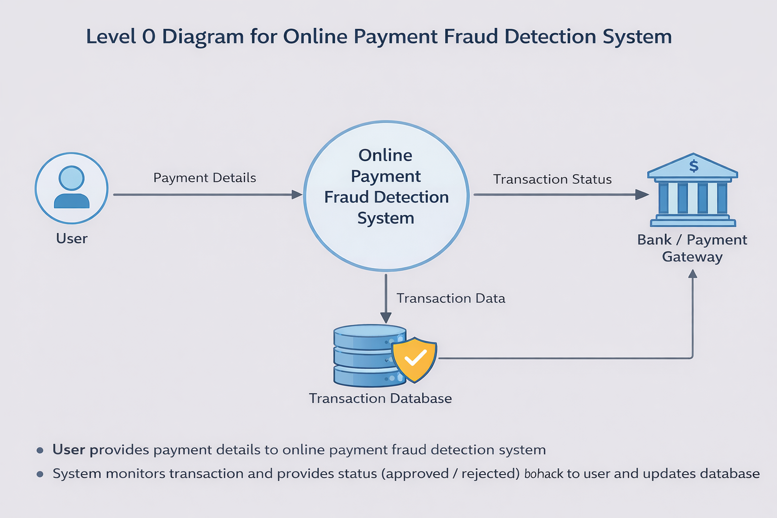

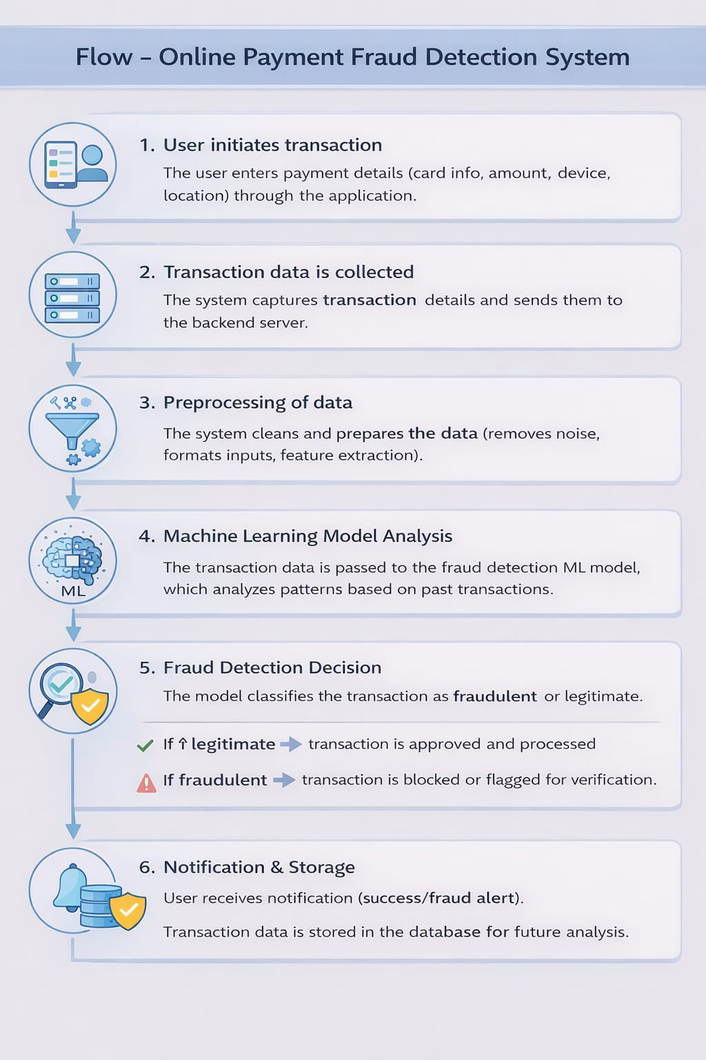

User Stories
Use
User Type | Functional Requirement (Epic) | User Story Number | User Story / Task | Acceptance Criteria | Priority | Release
Customer (Mobile User) | Registration | USN-1 | As a user, I can register using email & password | User account is created and dashboard is accessible | High | Sprint-1
 |  | USN-2 | As a user, I receive a confirmation email after registration | Email is received and verified successfully | High | Sprint-1
 |  | USN-3 | As a user, I can register using Google account | User can login via Google and access dashboard | Medium | Sprint-1
 |  | USN-4 | As a user, I can register using Facebook | User can login via Facebook successfully | Low | Sprint-2
 | Login | USN-5 | As a user, I can log in using email & password | User is authenticated and redirected to dashboard | High | Sprint-1
 |  | USN-6 | As a user, I can reset my password if forgotten | Password reset link is sent and updated successfully | High | Sprint-1
 | Dashboard | USN-7 | As a user, I can view my account balance | Updated balance is displayed correctly | High | Sprint-1
 |  | USN-8 | As a user, I can view recent transactions | Transaction history is visible | High | Sprint-1
 | Payment | USN-9 | As a user, I can make payments using UPI/Card/Wallet | Payment is processed successfully | High | Sprint-1
 |  | USN-10 | As a user, I receive confirmation after payment | Notification/SMS/email is received | High | Sprint-1
 |  | USN-11 | As a user, I can cancel a transaction (if pending) | Transaction is cancelled successfully | Medium | Sprint-2
 | Security | USN-12 | As a user, I receive OTP for secure transactions | OTP is generated and verified correctly | High | Sprint-1
 |  | USN-13 | As a user, I get fraud alerts for suspicious activity | Alert is triggered and user is notified | High | Sprint-2

